

Revolution Medicines announced updated clinical data for daraxonrasib (pan-RAS inhibitor) in mPDAC, including long-term 2L monotherapy follow-up and initial 1L monotherapy and chemotherapy combination results, supporting initiation of a three-arm P3 trial in Q4’25 (Press Release)
Key Take-Aways
- Overall, pan-RASi daraxonrasib (RMC-6236) continues to show promising efficacy in PDAC, but a challenging safety profile indicates lower dosing will be required in combination with SOC
- First 1L PDAC efficacy disclosure with daraxonrasib shows numerical improvement in response compared to historical SOC both as a monotherapy (ORR 47%) and combination (ORR 55%) with SOC gemcitabine-nab-paclitaxel (GnP), but improvement was modest as monotherapy and less than additive in combination
- The new 1L data also confirms that previously observed tolerability challenges at the 300mg 2L monotherapy dose persisted in front-line patients; as a result, daraxonrasib will use a lower dose while in combination with 1L SOC
  - 1L Monotherapy (300mg) dose modifications: 63%
  - 1L Combo daraxonrasib (200mg) dose modifications: 53% respectively
  - Mean dose-intensity was <90% in both cohorts for daraxonrasib
  - All-grade and Gr3+ TRAE rates of rash, stomatitis and diarrhea were elevated in both cohorts
- Proposed P3 trial design disclosed for the first time and includes experimental monotherapy and combination arms, highlighting potential lack of clear differentiation between mono and combo data
- In 2L PDAC, 10 additional months of follow-up (mF/U: 16.7mo) confirms previously disclosed PFS (8.1 – 8.5mos) and OS benefit (13.1 – 15.6mos) in RAS G12X and RASm, respectively, albeit in a single-arm study

Detailed Summary:

1L PDAC: Daraxonrasib Monotherapy (300 mg QD)

Metric | 1L RASm PDAC  (n=38 evaluable) | 1L SoC Chemo  (mFOLFIRINOX and GnP)
ORR | 47% | ~36 – 45%
DCR | 89% | ~60 – 70%
mFU | 9.3m | -

- Safety: 35% Grd3+ TRAEs, including rash (8%), diarrhea (10%), stomatitis (8%).

1L PDAC: Daraxonrasib + GnP (200 mg QD + standard dose GnP)

Metric | 1L RASm PDAC  (n=31 evaluable) | 1L SoC Chemo  (mFOLFIRINOX and GnP)
ORR | 55% | ~36 – 45%
DCR | 90% | ~60 – 70%
mFU | 6.9m | -

- Safety: 58% Grd3+ TRAEs, including rash (13%), diarrhea (13%), stomatitis (13%), anemia (23%)
- Dose rationale (200 mg with chemo):
  - Both 200 mg and 300 mg doses of daraxonrasib deliver high exposure and strong anti-tumor activity
  - For combination with GnP, the 200 mg dose was chosen to minimize overlapping toxicities (e.g., diarrhea, cytopenias) while still sustaining RAS inhibition
  - Patients transition to 300 mg monotherapy after ~4–6 cycles of chemo, when chemo benefit wanes, ensuring long-term RAS suppression

2L PDAC: Daraxonrasib Monotherapy (300mg QD)

Metric | RAS G12X (n=26) | All RASm (n=38) | 2L SoC Chemo  (mFOLFIRINOX and GnP)
ORR | 35% | 29% | 15 – 17%
DCR | 92% | 95% | ~30 – 50%
mPFS | 8.5m (6.7 – 10.5) | 8.1m (5.9 – 10.1) | 3.1 – 5.2m
mOS | 13.1m | 15.6m | 6.4 – 9.2m
mFU | 16.7m | 16.7m | -

- Safety profile consistent with previously reported data; no new safety signals were identified
- RASolute-302 (P3, 2L PDAC daraxonrasib vs investigators choice chemo): Company reiterated global enrollment completion in 2025 with expected 2026 data readout

P3 Trial Design and Catalysts
- RASolute-303 (P3, 1L PDAC): Planned initiation in Q4’25 with a three-arm design
  - Three-arm design: daraxonrasib monotherapy and daraxonrasib+GnP, each vs GnP control
  - Endpoints: PFS and OS; stratified by RAS mutation status
  - Protocol not yet finalized; details may change prior to trial start

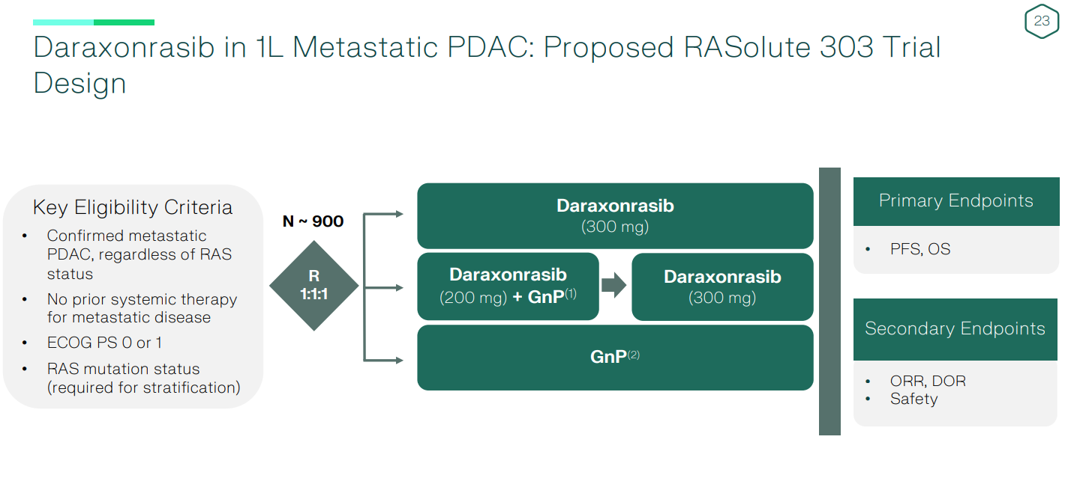

Q&A Highlights
- Mono vs combo efficacy: In 1L PDAC, monotherapy ORR 47% vs combo 55%, both ~90% DCR. P3 designed to test the hypothesis of whether patients benefit more from early combo or a sequential approach (daraxonrasib first, chemo later)
- Durability: 1L durability is not yet mature, but high DCR is encouraging. In 2L, OS >1 year reinforces belief in long-term benefit
- Dose rationale: 200 mg selected with GnP to minimize overlapping toxicities; patients then transition to 300 mg monotherapy after 4–6 cycles for sustained RAS inhibition
- Comparator choice: RevMed emphasized GnP vs FOLFIRINOX deliver similar survival; GnP chosen for global tolerability. Goal is to move the debate from “chemo vs chemo” to “chemo ± RAS inhibition”
- Other considerations: Resistance data not yet available (too few progressors); physician education will be key outside academic centers, but company expects data + approvals to drive uptake

Do not reply directly to this email. Please email Claudia Lanauze Torres, (claudia.lanauzetorres@abbvie.com ), Kristin Baldauf, (kristin.baldauf@abbvie.com) or Brock, Jesse (jesse.brock@abbvie.com) for questions or comments.

